📑 Hotel Booking Cancellations Report

|  |
| --- |
| Table of Contents  1. Business Problem 1  2. Assumptions 1  3. Research Questions 1  4. Hypotheses 2  5. Exploratory Data Analysis 2  5.1 Cancellation Rates by Hotel 2  5.2 Cancellation Trend by Month 2  5.3 ADR (Price) vs Cancellation 2  5.4 Cancellation Rate by Market Segment 2  6. Business Impact 2  7. Recommendations 2  8. Conclusion 3 |

## 1. Business Problem

City Hotel and Resort Hotel have experienced **high cancellation rates** between 2015–2017, resulting in:

**Lost revenue** (rooms left unoccupied)

**Operational inefficiencies** (staffing, inventory planning)

**Poor demand forecasting**

Our objective is to **identify the main drivers of cancellations** and provide **actionable recommendations** to minimize losses.

## 2. Assumptions

Data from **2015–2017** is representative of typical hotel operations.

No extraordinary events significantly bias the dataset.

Hotels are not yet applying advanced cancellation-mitigation strategies.

Cancellation behavior is primarily driven by pricing, lead time, and booking channels.

## 3. Research Questions

What variables most affect hotel reservation cancellations?

How can hotels reduce cancellations effectively?

How can insights support **pricing and promotional decisions**?

## 4. Hypotheses

**H1:** Higher prices (ADR) → more cancellations.

**H2:** Longer waiting lists / lead times → higher cancellations.

**H3:** Majority of cancellations originate from **offline/online travel agent channels**.

## 5. Exploratory Data Analysis

### 5.1 Cancellation Rates by Hotel

**City Hotel** has a **41.7% cancellation rate**, significantly higher than **Resort Hotel (27.8%)**.

Possible reason: City Hotel attracts **business/short-term guests**, who are more likely to change plans.

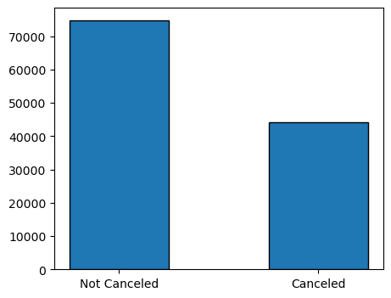

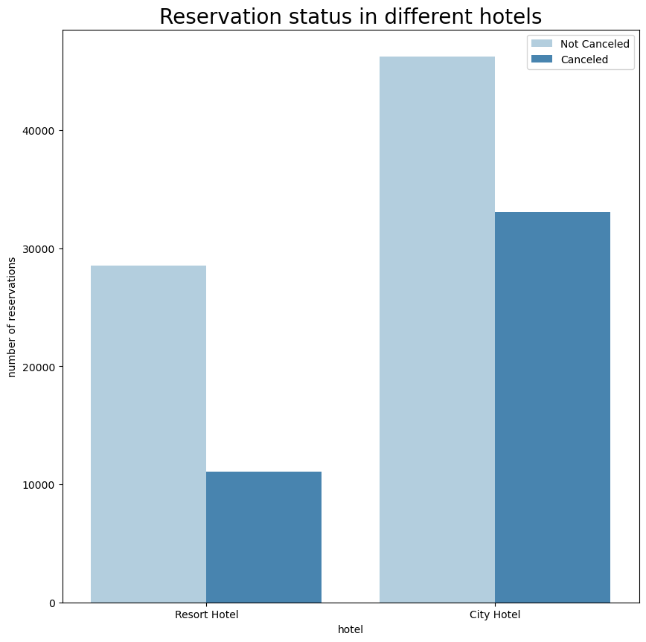

### 5.2 Cancellation Trend by Month

**April–August** shows the **highest cancellations (~40%)**, aligning with **peak summer demand**.

This suggests **seasonal overbooking risks**, requiring better **forecasting and deposit policies**.

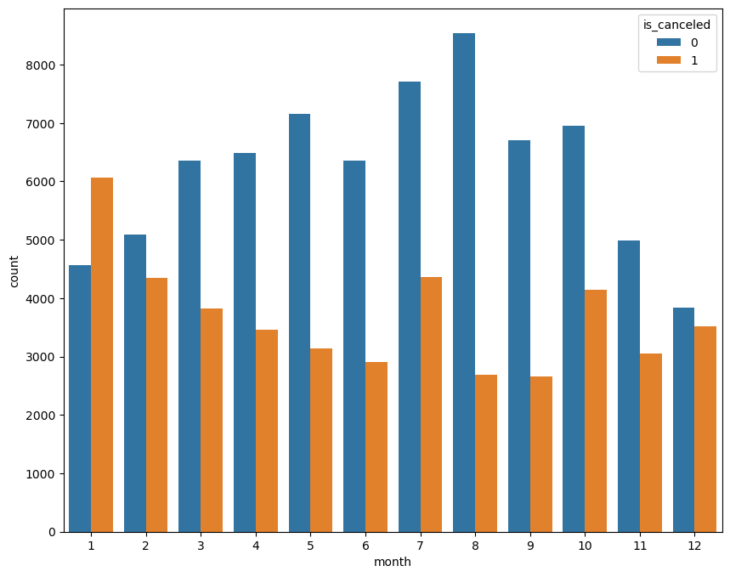

### 5.3 ADR (Price) vs Cancellation

Bookings with **higher ADR (room rates)** tend to have **more cancellations**.

Supports **Hypothesis 1** → Guests are price-sensitive and may cancel if they find cheaper alternatives.

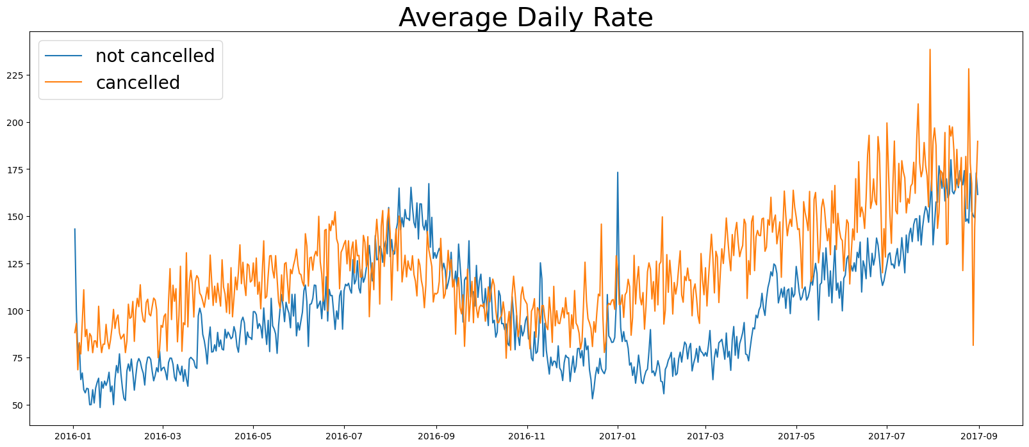

### 5.4 Cancellation Rate by Market Segment

**Groups (61%)** and **Online TA (37%)** segments dominate cancellations.

**Offline TA/TO** also contributes heavily (**34%**).

**Direct bookings** show **much lower cancellations** → encouraging direct sales could reduce losses.

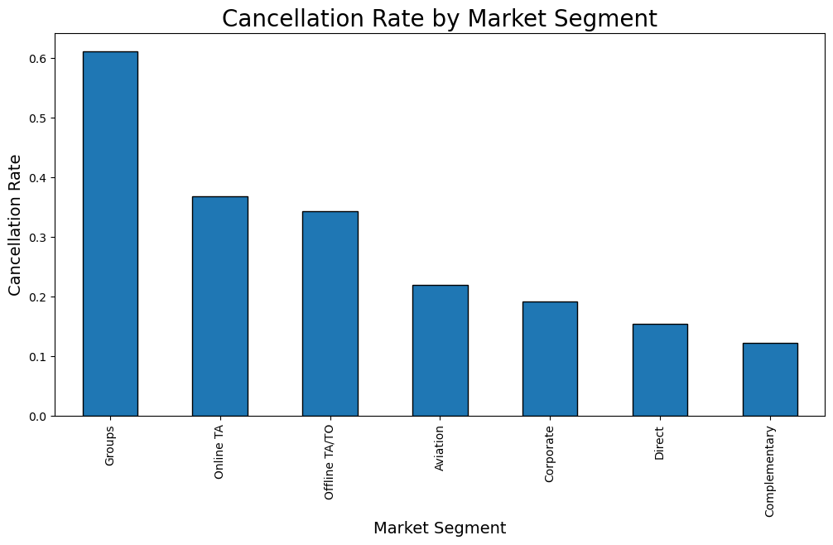

## 6. Business Impact

**TA/TO (Travel Agents/Tour Operators)** cancellations account for **~€22M of at-risk revenue**.

A **5% reduction in cancellations** could save **€1.86M** annually.

Improving cancellation policies in just **one segment** (TA/TO) can significantly boost hotel profitability.

## 7. Recommendations

**Dynamic Pricing & Forecasting**

Lower ADR for **long lead-time bookings**.

Use **predictive models** to identify high-risk cancellations.

**Deposit & Prepayment Policies**

Require **partial deposits** for TA/TO and group bookings.

Implement **non-refundable tiers** for peak months.

**Channel Strategy**

Reduce reliance on **TA/TO & online agents**.

Offer **discounts, loyalty points, or perks** for direct bookings.

**Operational Planning**

Adjust staffing and inventory planning based on **seasonality** and **cancellation forecasts**.

Overbook strategically in high-cancellation segments.

## 8. Conclusion

This analysis highlights that **cancellations are not random**—they are strongly linked to:

**Booking channel** (TA/TO & groups dominate)

**Seasonality** (summer peaks)

**Pricing strategies** (higher ADR = higher cancellations)

By adopting **smarter pricing policies, stricter cancellation terms, and incentivizing direct bookings**, City and Resort Hotels could **save up to €1.86M annually** and **improve occupancy efficiency**.

✅ This report demonstrates how **data analysis + business context** can help hotels **translate data into financial value**